RIVER VALLEY HIGH SCHOOL
General Certificate of Education Advanced Level
Preliminary Examination 2026
Higher 2
H

GEOGRAPHY 9173/01
Paper 1 14 September 2026
INSERT 3 hours

READ THESE INSTRUCTIONS FIRST

This Insert contains all the Resources referred to in the questions.

___________________________________________________________________
This document consists of 6 printed pages.

[Turn over

Resource 1A for Question 1
Attractions of Bengaluru to IT TNCs
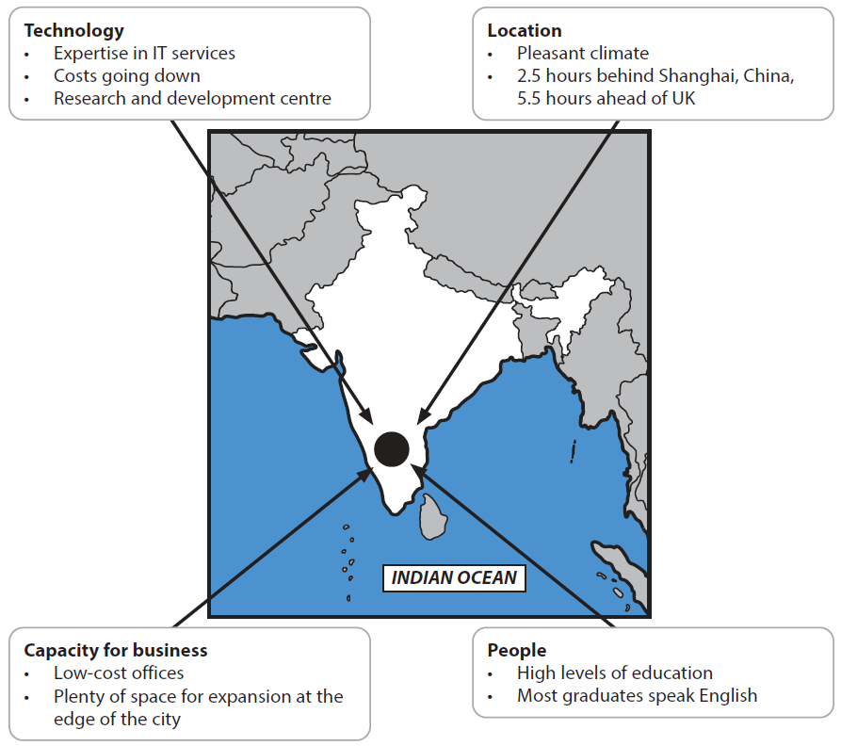

Resource 1B for Question 1
Opinions about costs and benefits of offshoring and outsourcing industry to Bengaluru
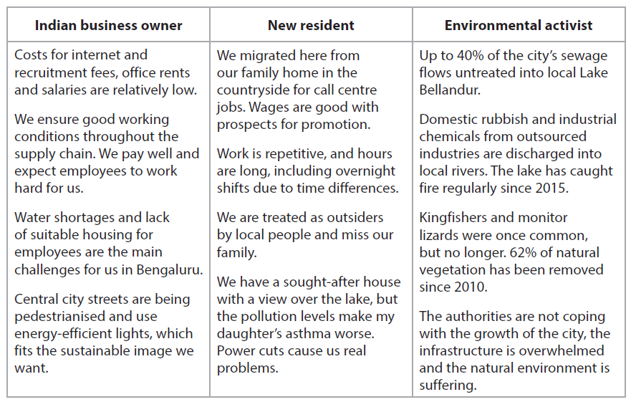

Resource 2 for Question 1
Value of international trade per capita (in US$) across selected countries in 2019
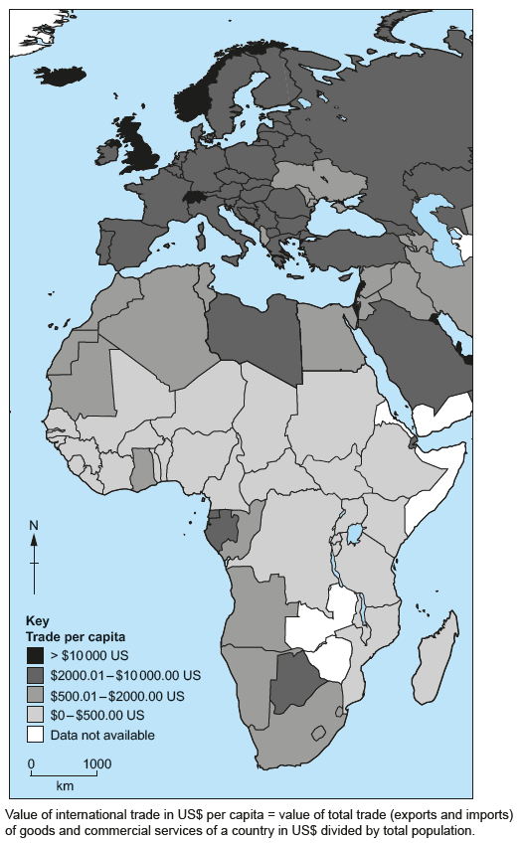

Resource 3 for Question 1
Number of Apple suppliers by region in 2023 and 2024
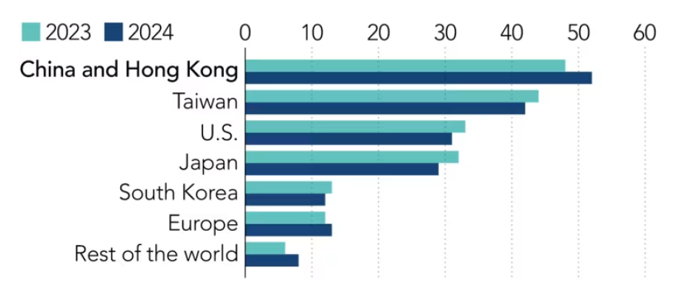

Resource 4 for Question 1
An extract from Apple’s 2026 report on labour and environmental conditions within its supply chain
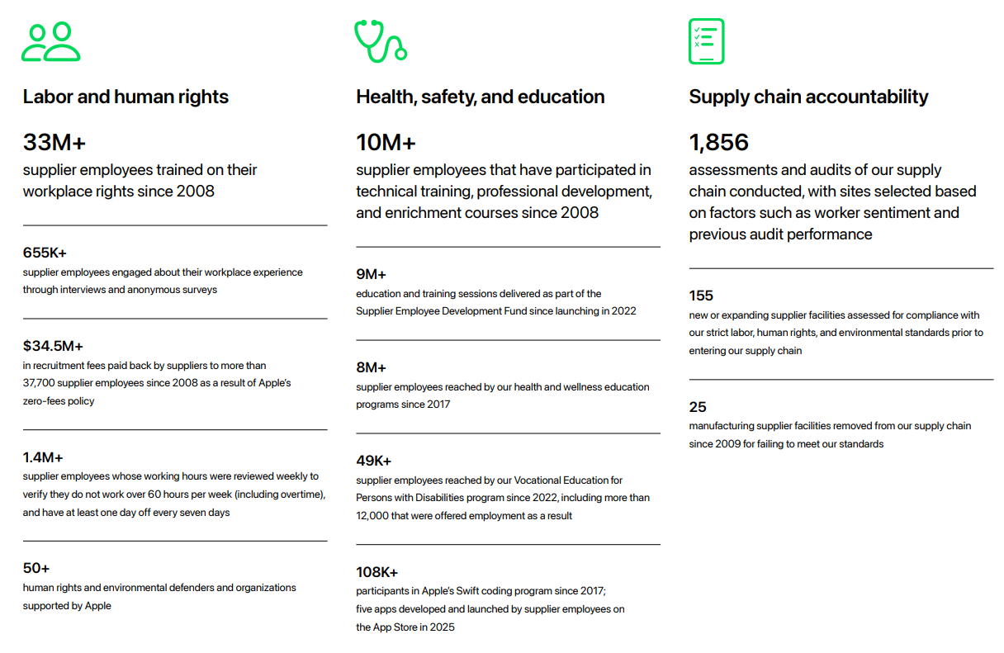

Resource 5 for Question 2
Variation in hydrological outputs and pathways among different tree cover extents

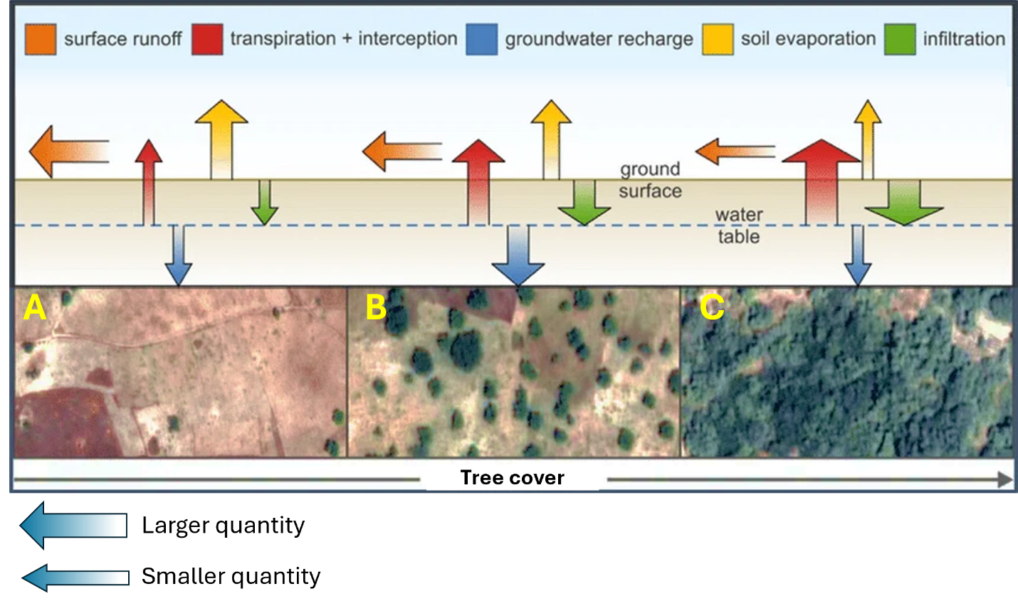

Resource 6 for Question 2
Map of Mekong Delta with indications of the historical coastlines of the delta

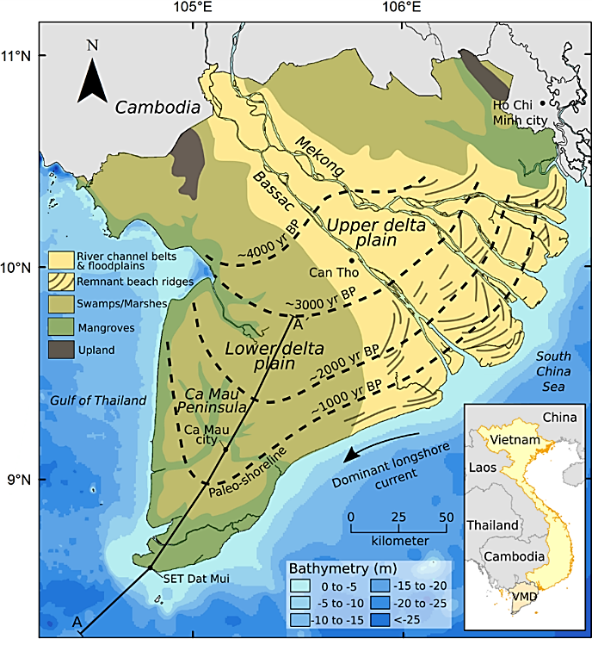
Resource 7 for Question 2
Changes in mangrove areas and water surfaces for aquaculture in the Mekong Delta between 1950 and 2015
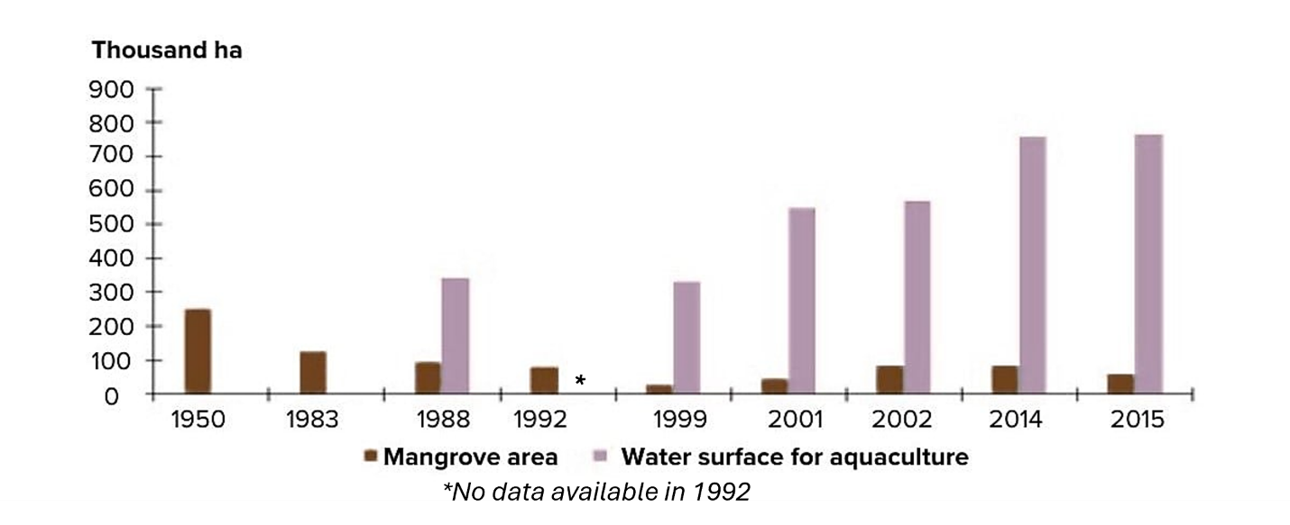

Resource 8 for Question 2
Primary environmental pressures on the Vietnamese Mekong Delta

